How to analyze a speech
Forsiden » Engelsk » Analyse » How to analyze a speech
Here are a number of things you should look for when you are to analyze a speech. Beside that, you should, of course, keep your eyes and ears open for anything interesting that can relate to the elements of the rhetorical pentangle.
Beware that if you have the speech on video (or in an audio file) — as you may have, for instance, in your exam assignment — there will be additional text-external elements to look for in terms of appearance, self presentation and impression management.

NB: Never content yourself with just pointing out the following characteristics in the speech! Pointing them out should always be accompanied by an explanation of how they work in the context, and a qualified guess at why the speaker has used them here.

Also see:
- Rhetorical terms
- Forms of appeal

The Communication Situation
- Who is speaking to whom on what occasion, in what language and with what intention?
  - Take notes to each heading in the rhetorical pentangle:
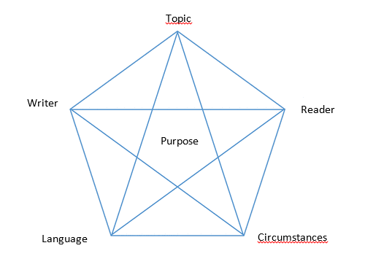
Speaker | What do you know/what can you find out about the speaker as a person?
Audience | What sort of people constitute the audience?
Circumstances | On what occasion is the speech made? Under what circumstances (physically/politically/etc.)?
Topic | What is the speech about?
Language | What sort of language (vocabulary, style, syntax) does the speaker use?
Purpose | What seems to be the speaker's purpose?

Genre
- What sort of speech is it?
  - a political speech
  - an informative speech
  - a celebratory speech

Content/topic
- What is the speech about?
  - Give a brief outline.
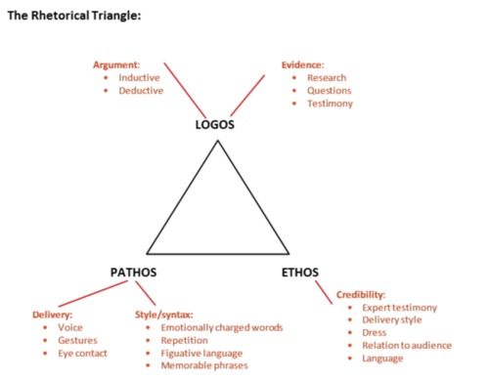

Structure
- How is the speech structured?
  - Introduction – body – conclusion
  - Is there a governing idea running through the speech?

Argumentation
- How does the speaker build his argumentation?
  - What is the central claim/what are the central claims?
  - What grounds are given?
  - What kinds of warrants, backing, qualifiers and rebuttals are used?

Modes of persuasion/forms of appeal
- Logos
- Pathos
- Ethos

Stylistical devices
- Repetition (triads/the rule of three?)
- Imagery
- Contrast
- Irony/sarcasm

Selection of words
- Word classes:
  - Verbs
  - Nouns
  - Adjectives
- High/low style
- Technical/specialized/professional language
- …

Syntax
- Short/long sentences
- Hypotaxis/parataxis (See definitions here)

Coherence
- Do the various parts of the speech relate logically?

Cohesion:
- How are the individual parts tied together?
  - What connecting words are used?
  - How does referencing work? (e.g. use of personal pronouns)

Text-external factors
- Appearance:
  - How does the speaker stand or move about?
  - How is the speaker dressed?
  - Does the speaker appear emotional or detached? How?
  - Anything noteworthy about the speaker's gestures?
  - Anything noteworthy about the speaker's facial expressions?
- Which of the above do you consider circumstantial?
- Which do you consider part of a strategy for self presentation or impression management?

Evaluation
- Is the speech succesful?
  - Is it a good speech?
  - Does it communicate its intended message?
  - Does it hit its target audience?
  - Does it fit the occasion?
  - Is it convincing?
  - Is the argumentation solid?
  - Is the use of logos, ethos and pathos balanced?
  - Is language and the use of stylistical devices balanced?

